2520030191
B Shammruth
DDL, DML, DCL, TCL Commands

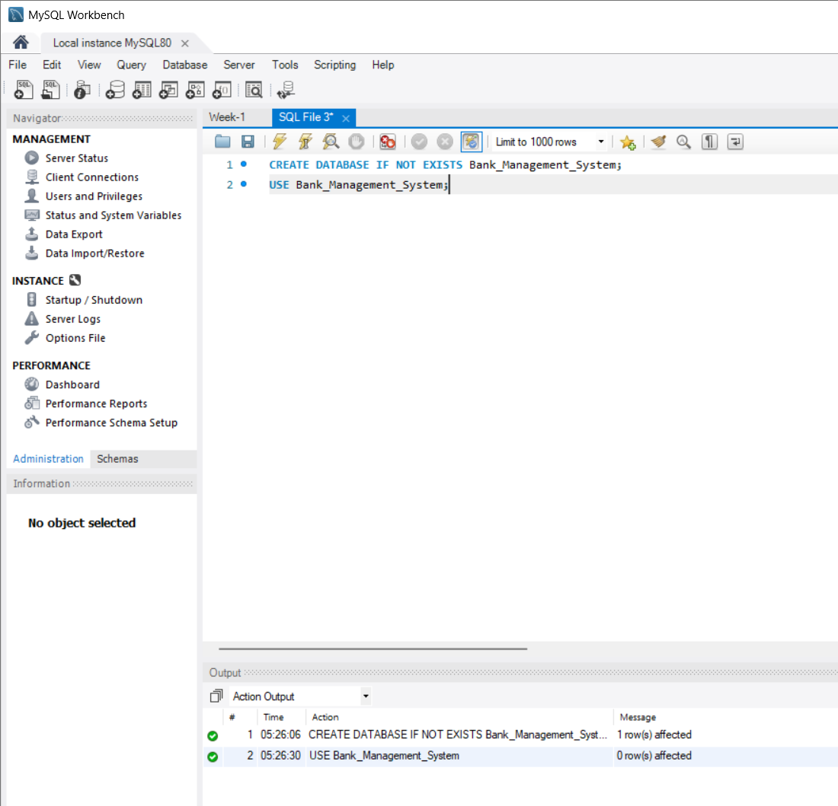

QUESTION 1 - CREATE TABLE
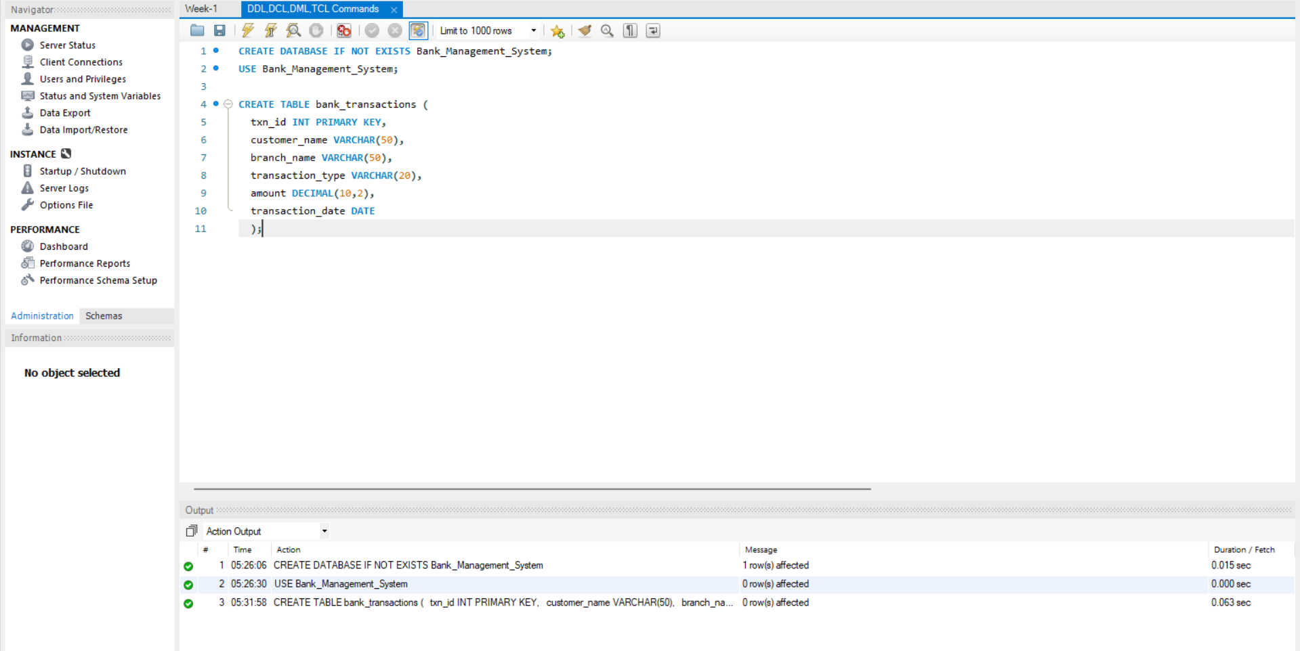

QUESTION 2 - ALTER TABLE ADD COLUMN
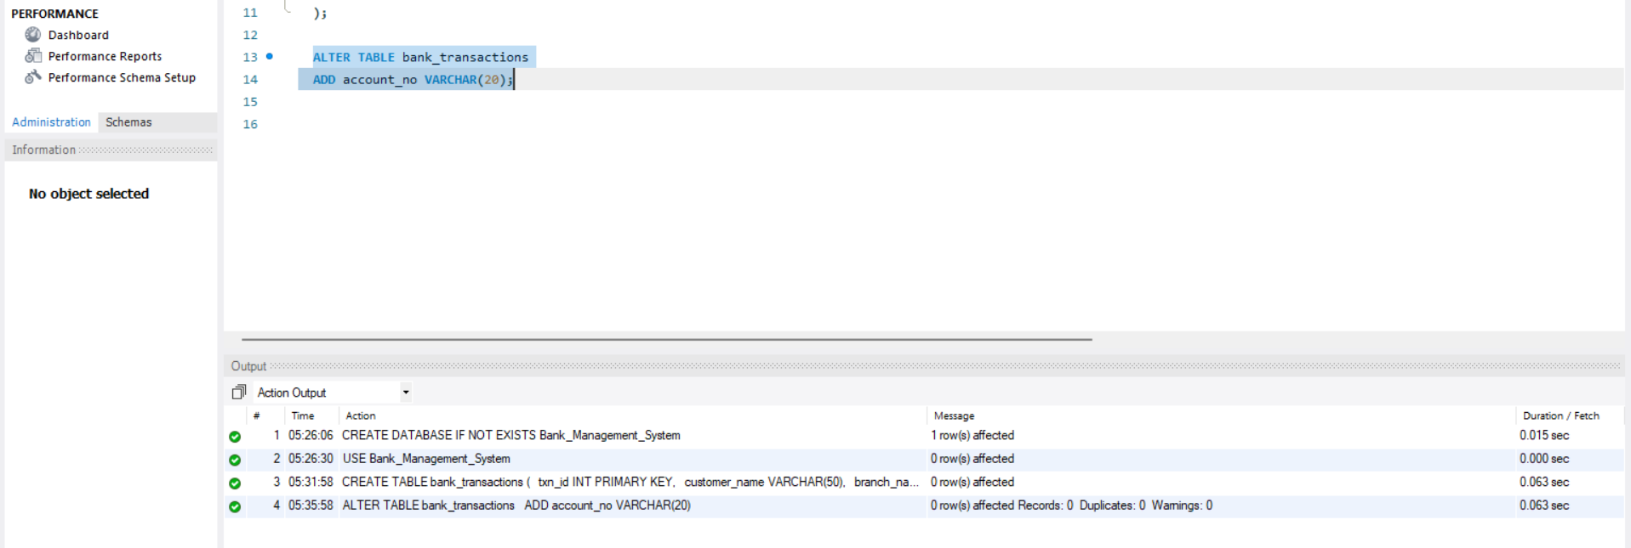

QUESTION 3 - ALTER TABLE MODIFY COLUMN

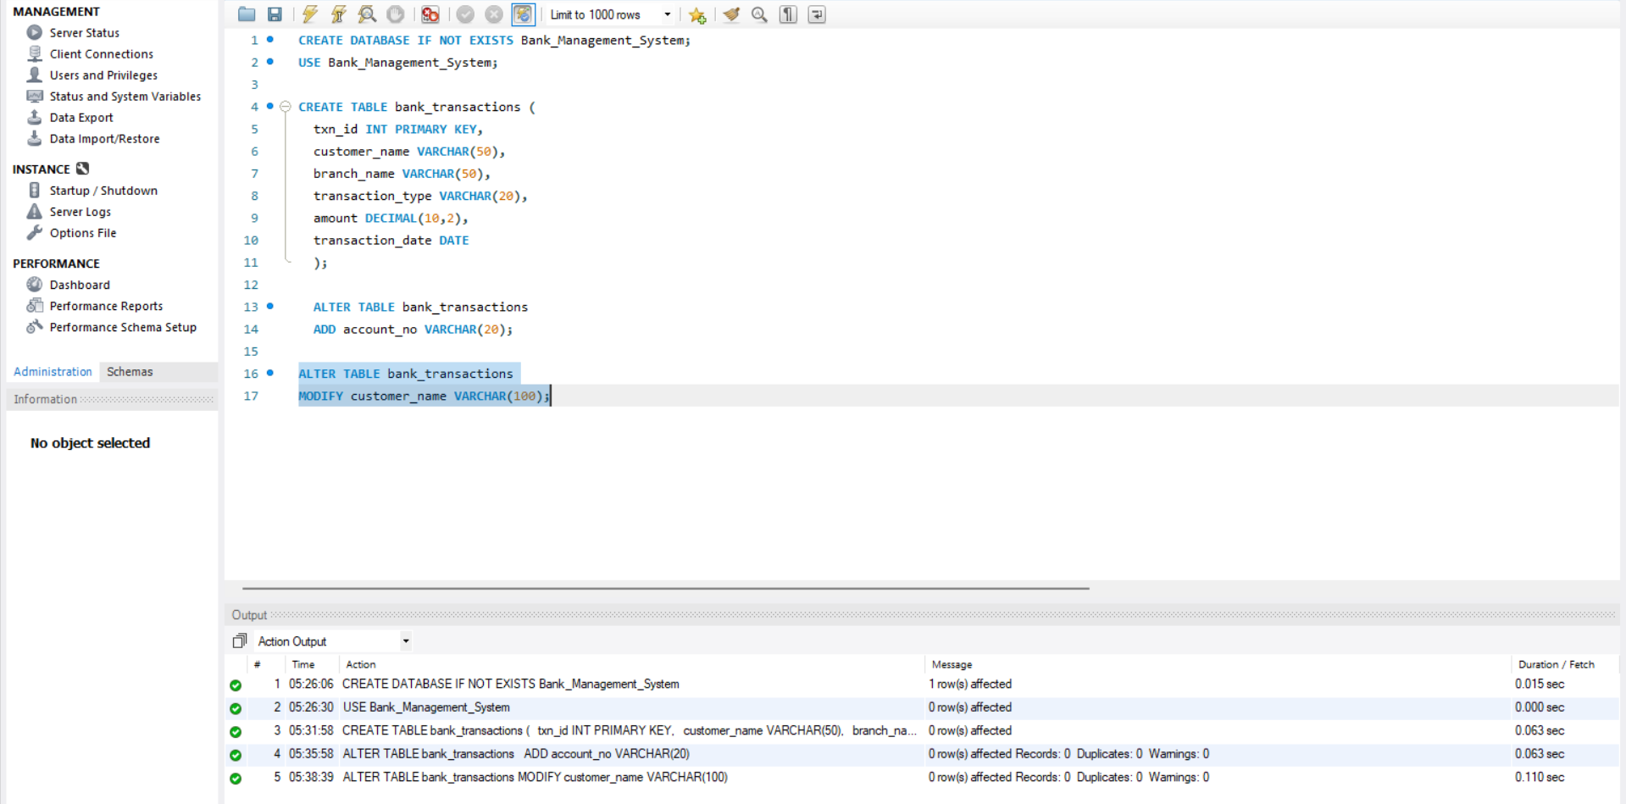
QUESTION 4 - RENAME TABLE
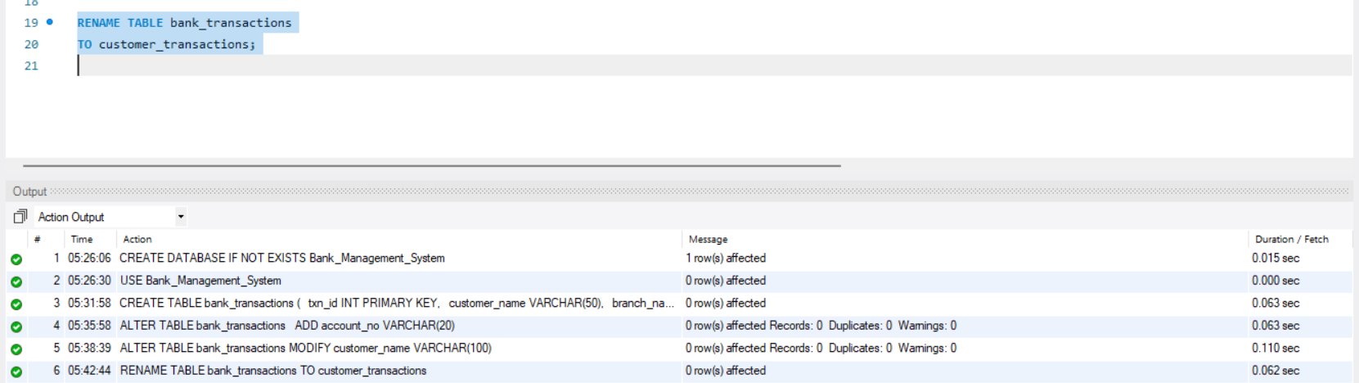

QUESTION 5 - TRUNCATE TABLE
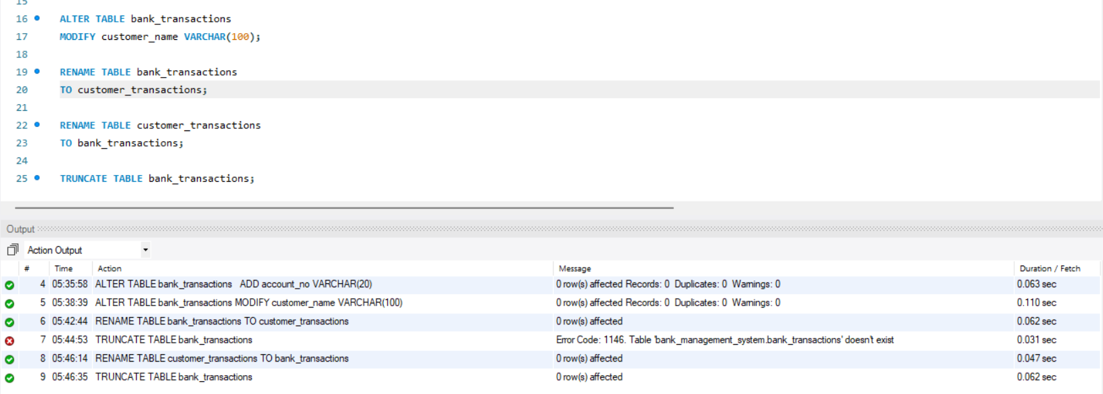

QUESTION 6 - DROP TABLE
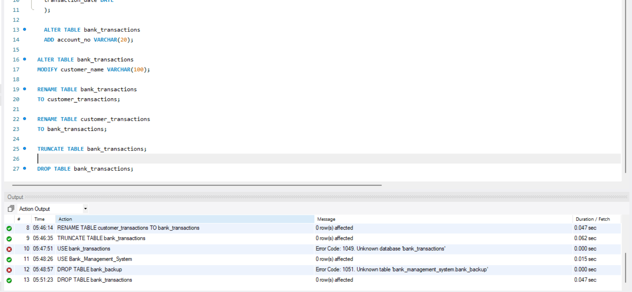

SECTION 2 : DML (DATA MANIPULATION LANGUAGE)
STEP 1 : INSERT SAMPLE DATA.
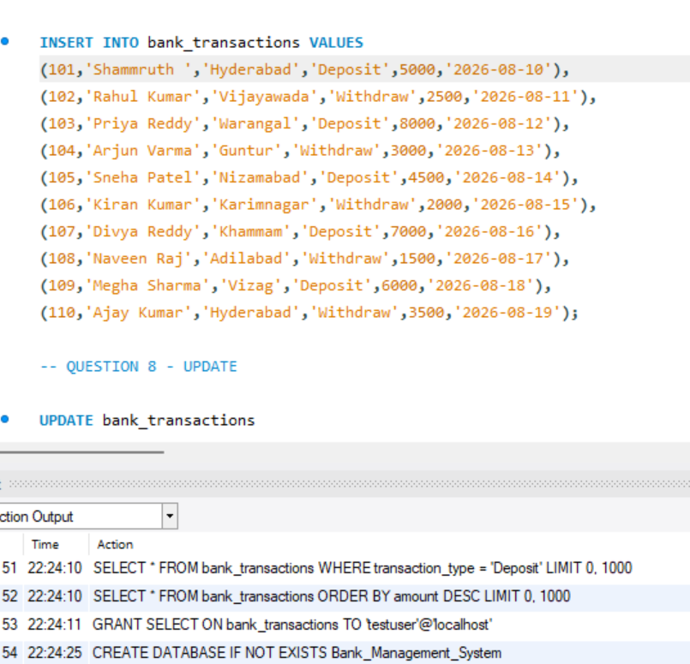

QUESTION 7 – INSERT
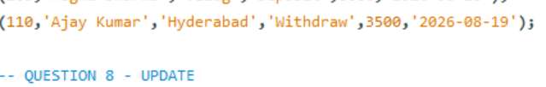
QUESTION 8 – UPDATE
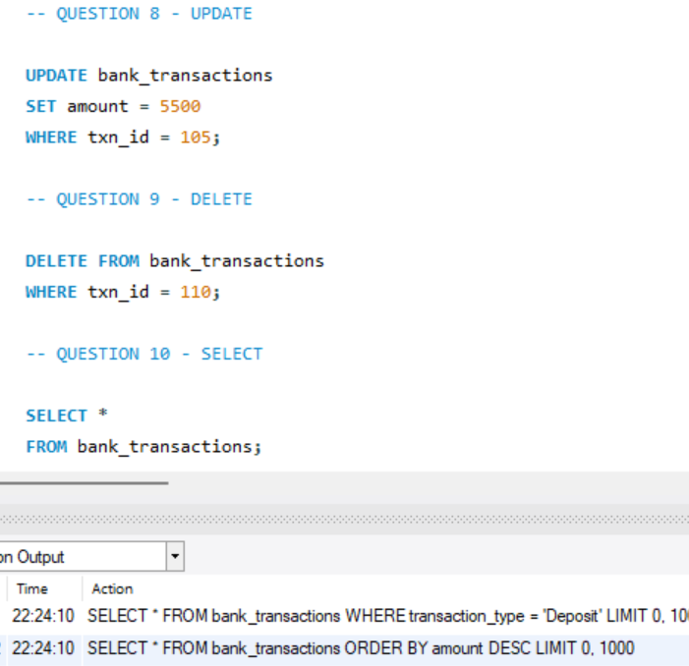
QUESTION 9 – DELETE
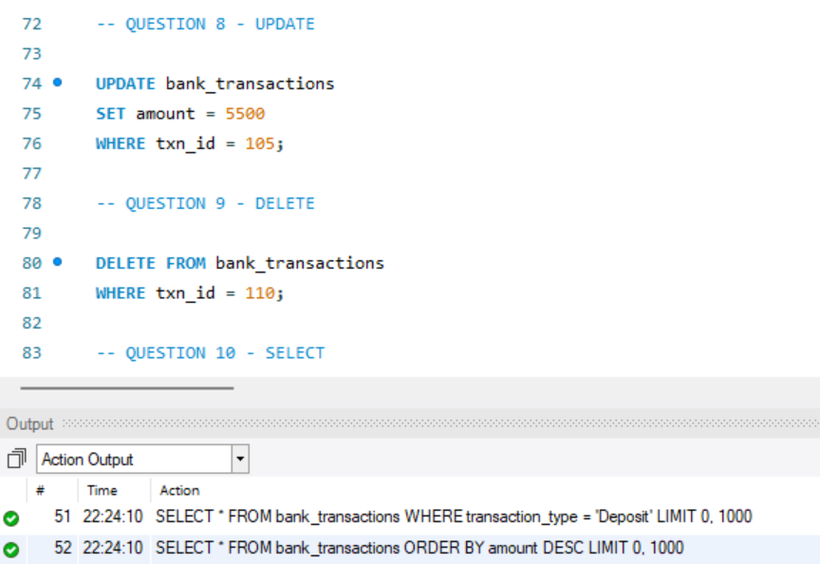
QUESTION 10 – SELECT
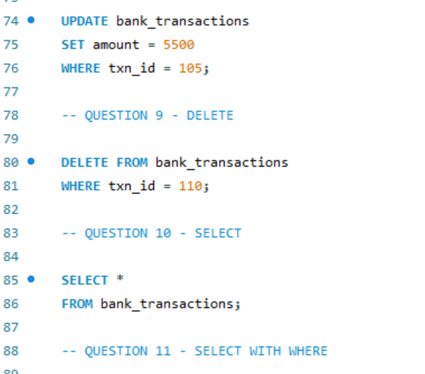
QUESTION 11 - SELECT WITH WHERE
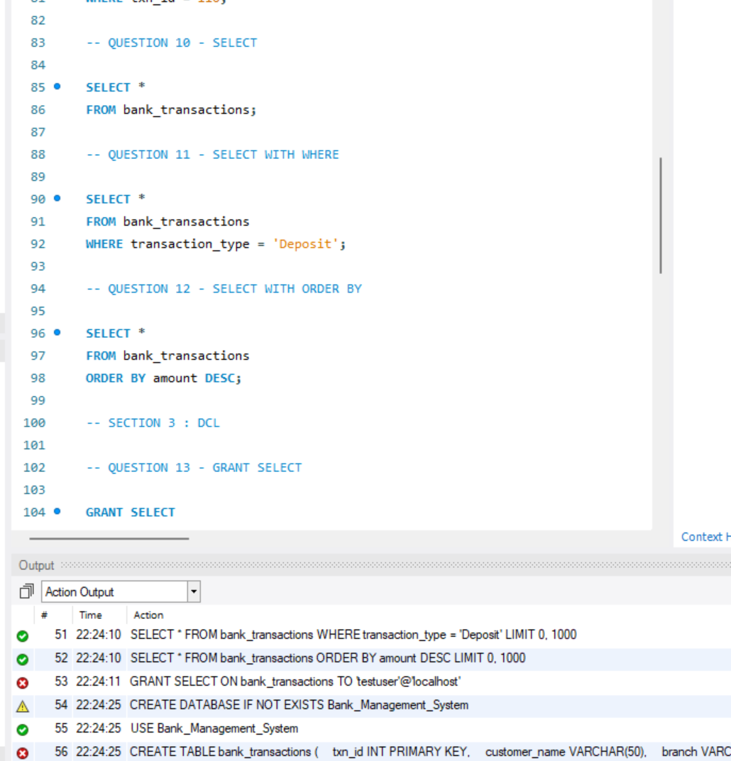
QUESTION 12 - SELECT WITH ORDER BY
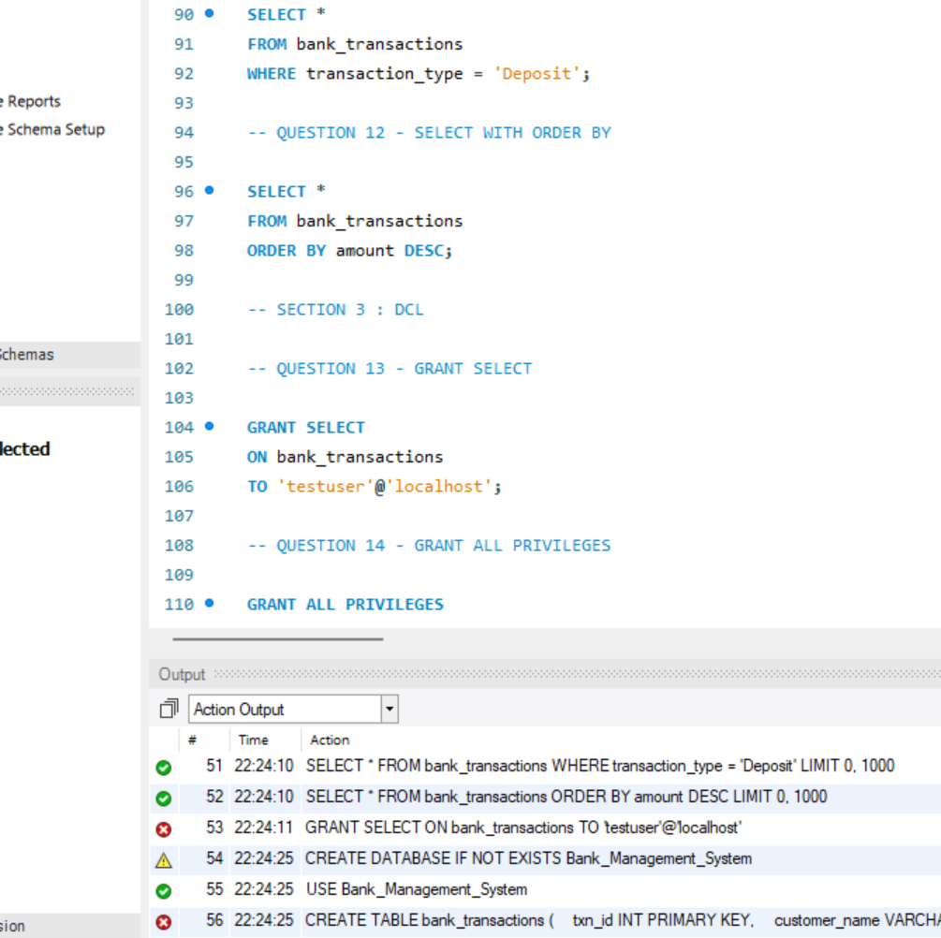
SECTION 3 : DCL (DATA CONTROL LANGUAGE)
QUESTION 13 - GRANT SELECT
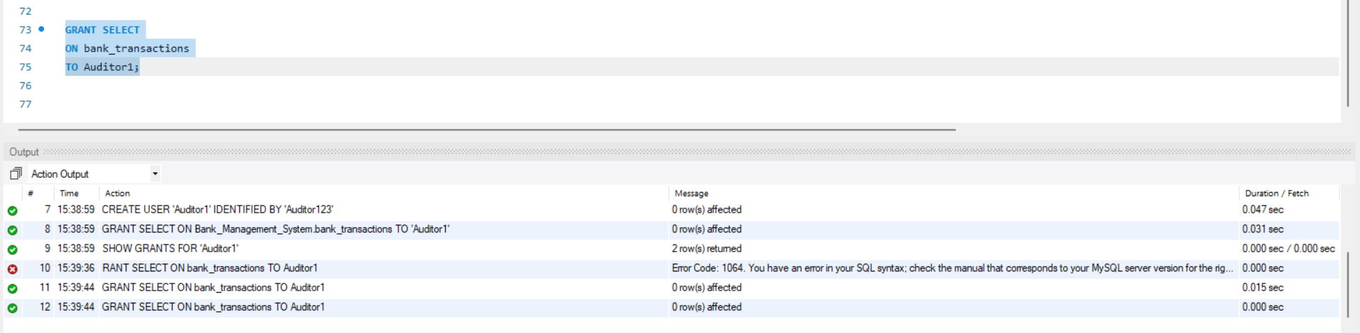
QUESTION 14 - GRANT ALL PRIVILEGES
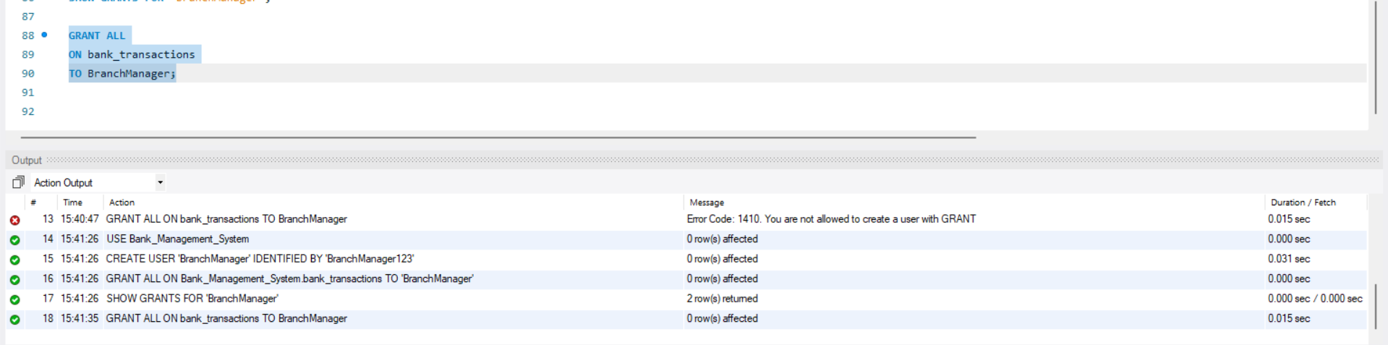
QUESTION 15 - REVOKE SELECT
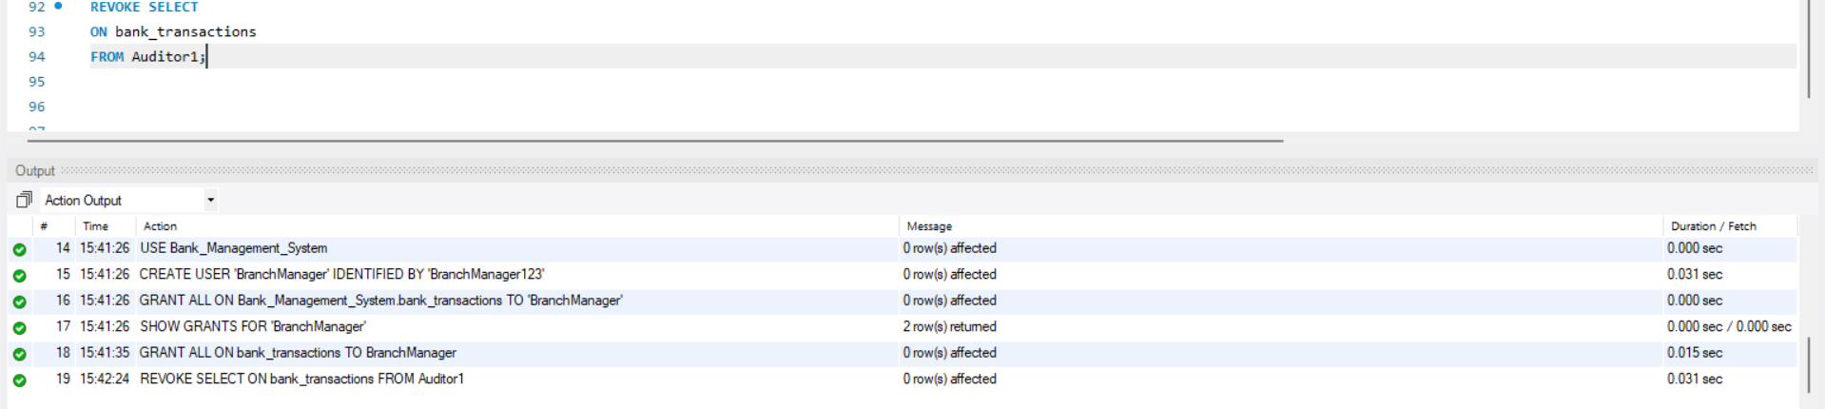
QUESTION 16 - REVOKE ALL
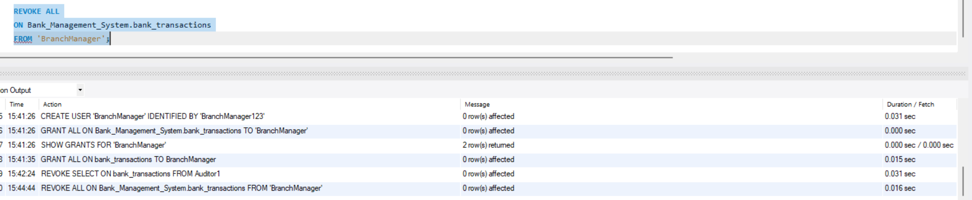

SECTION 4 : TCL (TRANSACTION CONTROL LANGUAGE)
QUESTION 17 – COMMIT
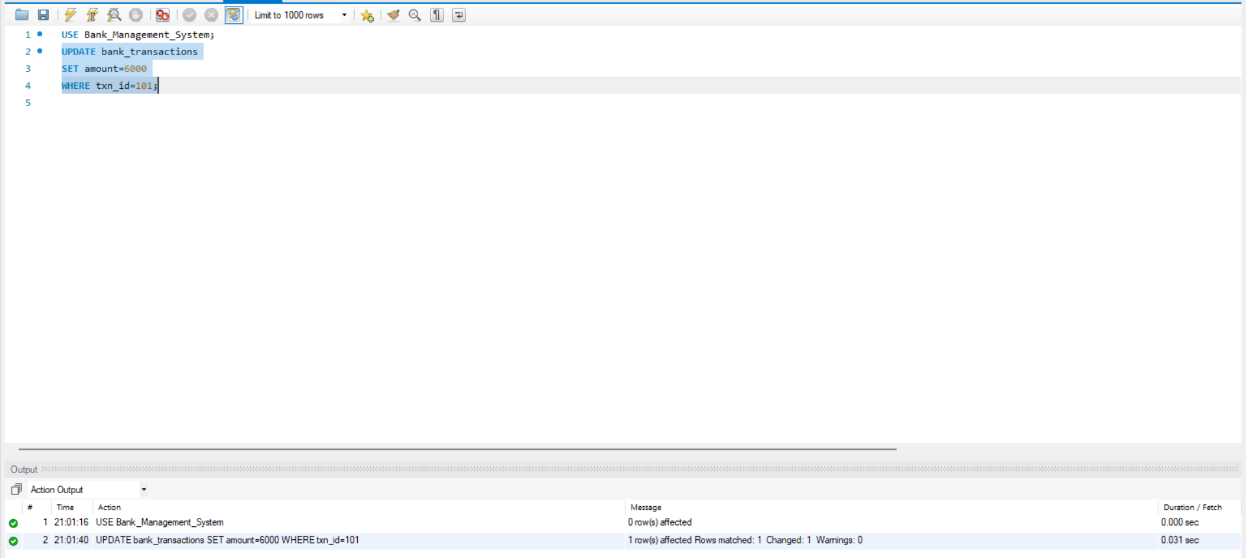
QUESTION 18 – SAVEPOINT
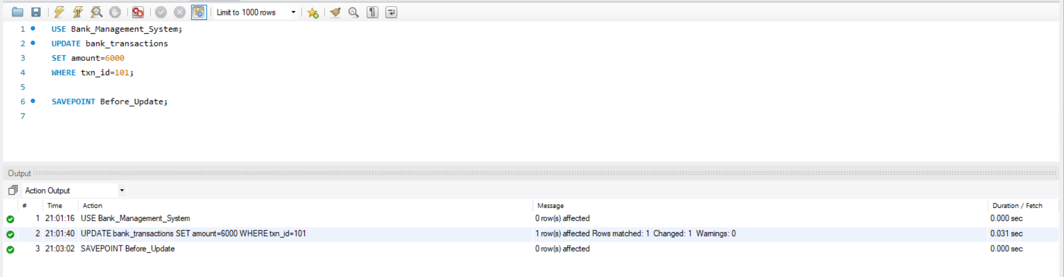
QUESTION 19 - ROLLBACK TO SAVEPOINT
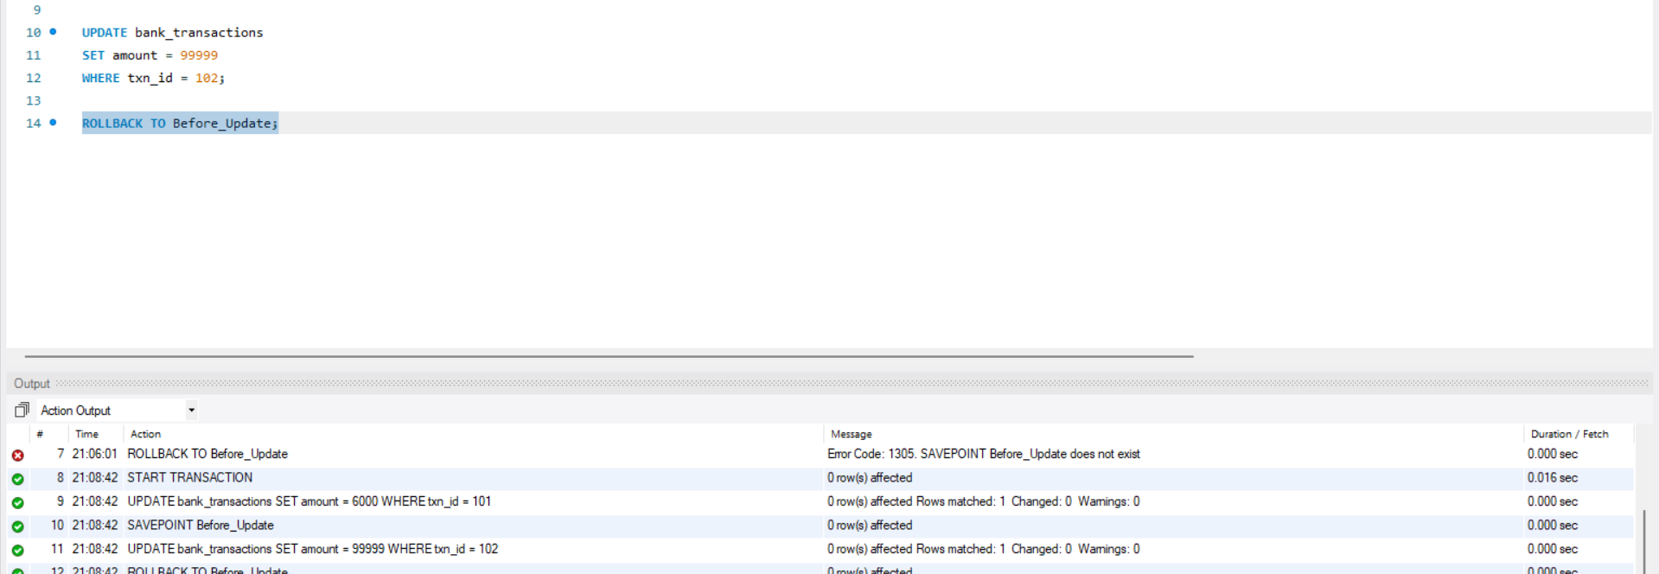
QUESTION 20 - FULL TCL EXAMPLE
